# 

# 

# RKE (Remote Keyless Entry)

|  |  |  |  |  |  |
| --- | --- | --- | --- | --- | --- |
| **Ver.Rel. No.** | **Release Date** | **Prepared By** | **Reviewed By** | **Approved By** | **Remarks** |
| 1 | 11-Mar-2022 | Malakalapalli Nagendra |  |  |  |
| 2 | 11-Mar-2022 | Indrani V |  |  |  |
| 3 | 11-Mar-2022 | Sahana Managuli |  |  |  |
| 4 | 11-Mar-2022 | Manojkumar Vadri |  |  |  |

**CONTENT Page.no**

1. INTRODUCTION . . . . . . . . . . . . . . . . . . . . . . . . . . . . . 03-04
   1. Description
   2. Features
   3. Swot Analysis and 5W’s 1H
2. REQUIREMENTS . . . . . . . . . . . . . . . . . . . . . . . . . . . . . . . . . . .04
   1. High Level Requirements
   2. Low level Requirements
3. ARCHITECTURE. . . . . . . . . . . . . . . . . . . . . . . . . . . . . . . 05-07
   1. Behavioural Diagram
      1. High level Flow Chart Behavioural Diagram
      2. Low level Flow Chart Behavioural Diagram
   2. Structural Diagram
      1. Use case Structural Diagram
      2. Functional Diagram
4. SYSTEM TEST PLAN . . . . . . . . . . . . . . . . . . . . . . . 07-08
   1. High Level Test Plan
   2. Low Level Test Plan
5. IMPLEMENTATION . . . . . . . . . . . . . . . . . . . . . . . . . . . . 08-11
6. APPLICATION. . . . . . . . . . . . . . . . . . . . . . . . . . . . . . . . . . . 11
7. REFERENCES . . . . . . . . . . . . . . . . . . . . . . . . . . . .11

**RKE (Remote Keyless Entry)**

**1. INTRODUCTION**

In our modern society comfort became a standard. This comfort, especially in cars can only be achieved by equipping the car with more electronic devices. Almost all modern cars can be locked or unlocked with a Remote Keyless System. A Remote Keyless System consists communicates wirelessly with the car receiver that is responsible for controlling doors of the car.

### **1.1 Description**

An RKE is some kind of an electronic lock which is alternative to using a traditional mechanical key that controls access to vehicle. A Remote Keyless Entry System consists of a key fob and a car transceiver that locks and unlocks the vehicle. The user presses a button on the key fob to lock or unlock the car instead of locking or unlocking the car with a traditional key.

### **1.2 Features**

* Locks the car
* Unlocks the car
* Contains anti-theft system to prevent thieves from intercepting and spoofing the telegrams
* Better Security

### **1.3 SWOT Analysis**

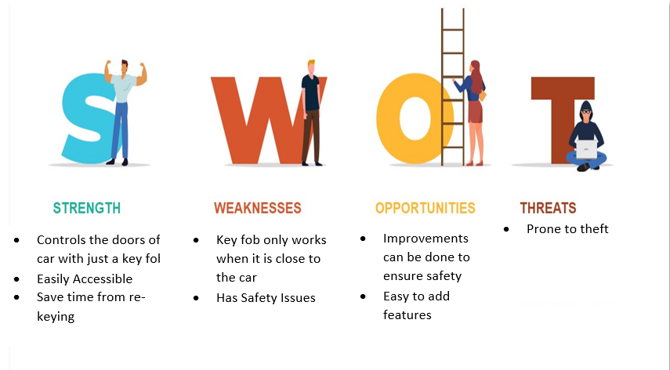

**5W's 1H**

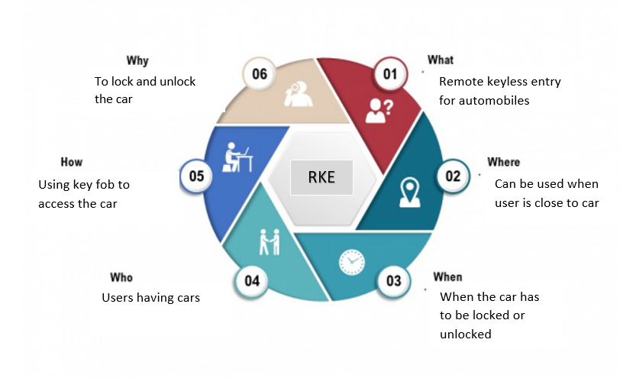

**2. REQUIREMENTS**

* **2.1 High Level Requirements**

|  |  |  |
| --- | --- | --- |
| **S.NO** | **HLR_ID** | **Description** |
| 1 | HLR-1 | User shall be able to lock the door using key fob |
| 2 | HLR-2 | User shall be able to unlock the door using key fob |
| 3 | HLR-3 | User shall be able to activate or deactivate the alarm |
| 4 | HLR-4 | User shall be able to approach light |

* **2.2 Low Level Requirements**

|  |  |  |
| --- | --- | --- |
| **S.NO** | **LLR_ID** | **Description** |
| 1 | LLR-1 | When user presses the button, all the LEDs shall glow indicating that door is locked |
| 2 | LLR-2 | When user presses the button twice, all the LEDs shall go off indicating that door is unlocked |
| 3 | LLR-3 | When user presses the button thrice, all the LEDs shall on in clockwise manner |
| 4 | LLR-4 | When user presses the button four times, all the LEDs shall on in anti-clockwise manner |

**3. ARCHITECTURE**

**3.1 Behavioural Diagram**

**3.1.1 High Level Flow Chart Behavioural Diagram**

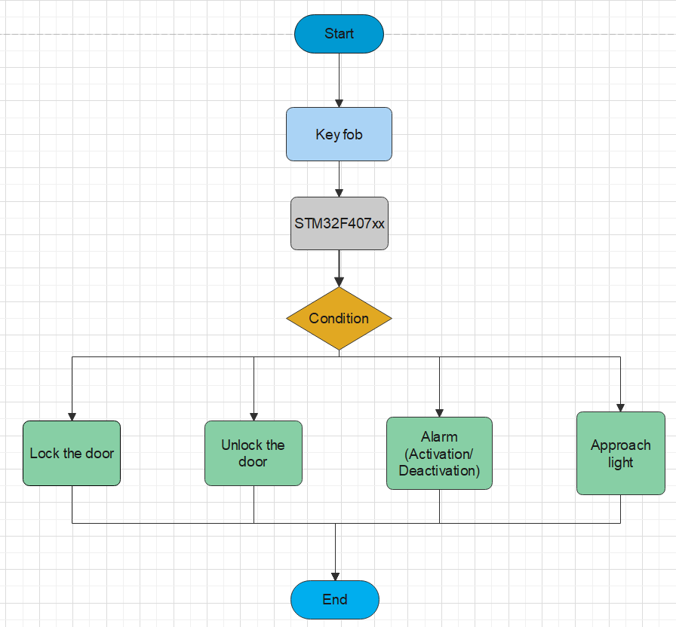

**3.1.2 Low level Flow Chart Behavioural Diagram**

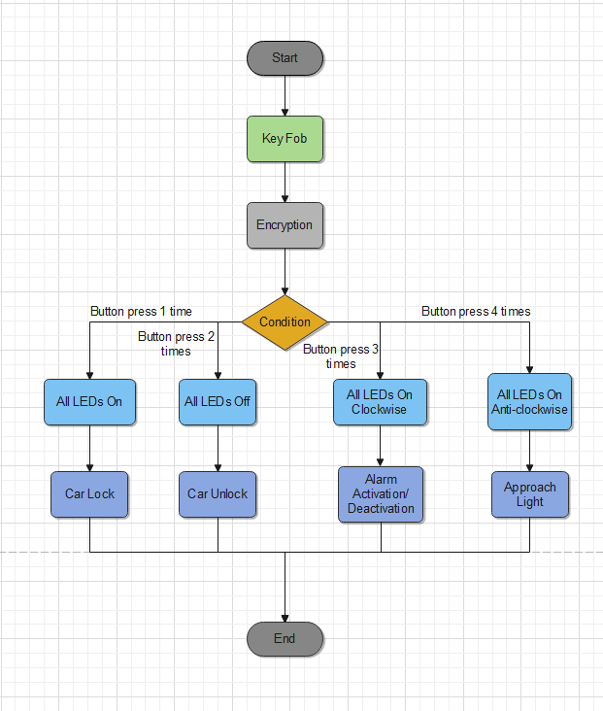

**3.2 Structural Diagram**

**3.2.1 Use Case Structural Diagram**

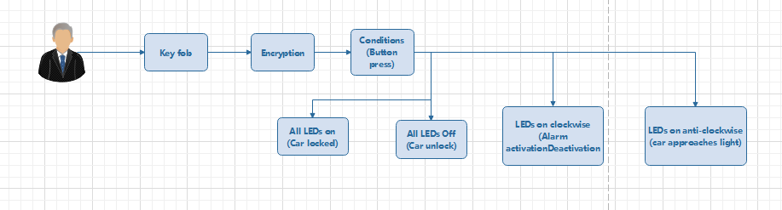

**3.2.2 Functional Diagram**

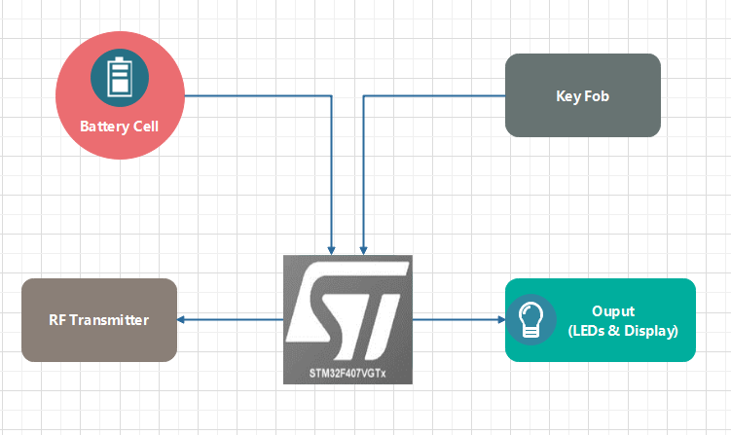

**4. SYSTEM TEST PLAN**

|  |  |  |  |  |  |
| --- | --- | --- | --- | --- | --- |
| Test_ID | Description | Input | Expected O/P | Actual O/P | Status |
| TD_01 | Car Lock | Button Press "1 Time" | LOCK | LOCK | Pass ✅ |
| TD_02 | Car Unlock | Button Press "2 Times" | UNLOCK | UNLOCK | Pass ✅ |
| TD_03 | Alarm Activation/Deactivation | Button Press "3 Times" | ALARM ACTIVATION/DEACTIVATION | ALARM ACTIVATION/DEACTIVATION | Pass ✅ |
| TD_04 | Approach Light | Button Press "4 Times" | APPROACH LIGHT | APPROACH LIGHT | Pass ✅ |

**4.1 High Level Test Plan**

## **4.2 Low Level Test Plan**

|  |  |  |  |  |  |
| --- | --- | --- | --- | --- | --- |
| Test_ID | Description | Input | Expected O/P | Actual O/P | Status |
| TD_01 | Car Lock | Button Press "1 Time" | All LED's "ON" | All LED's "ON" | Pass ✅ |
| TD_02 | Car Unlock | Button Press "2 Times" | All LED's "OFF" | All LED's "OFF" | Pass ✅ |
| TD_03 | Alarm Activation/Deactivation | Button Press "3 Times" | All LED's "ON CLOCKWISE" | All LED's "ON CLOCKWISE" | Pass ✅ |
| TD_04 | Approach Light | Button Press "4 Times" | All LED's "ON ANTI-CLOCKWISE" | All LED's "ON ANTI-CLOCKWISE" | Pass ✅ |

**5. IMPLEMENTATION**

**Figure 5.1 Simulation Image**

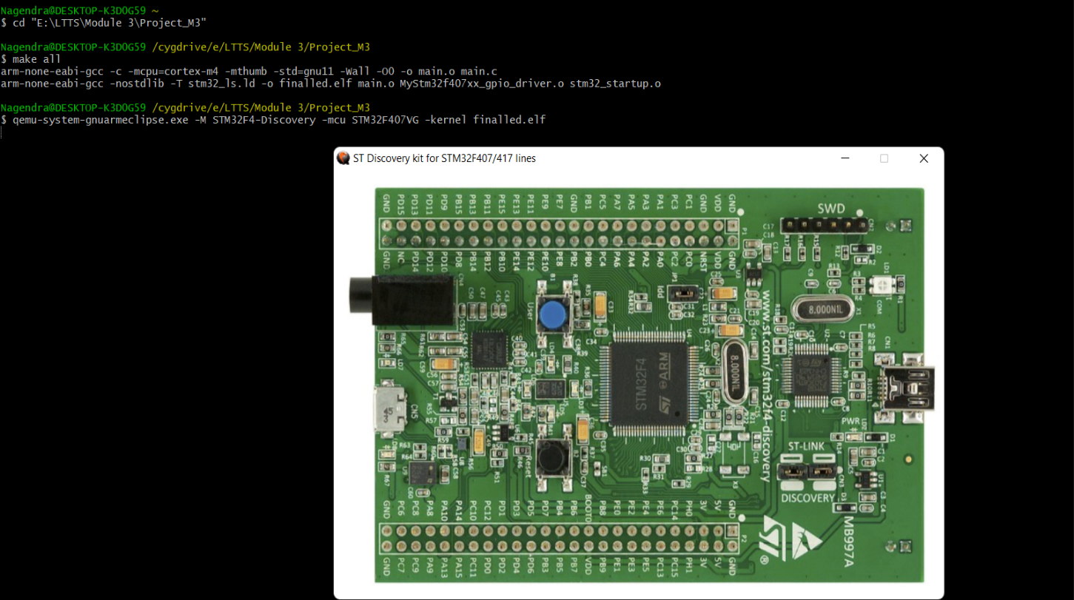

**Figure 5.2 Button pressed once hence all LEDs are on**

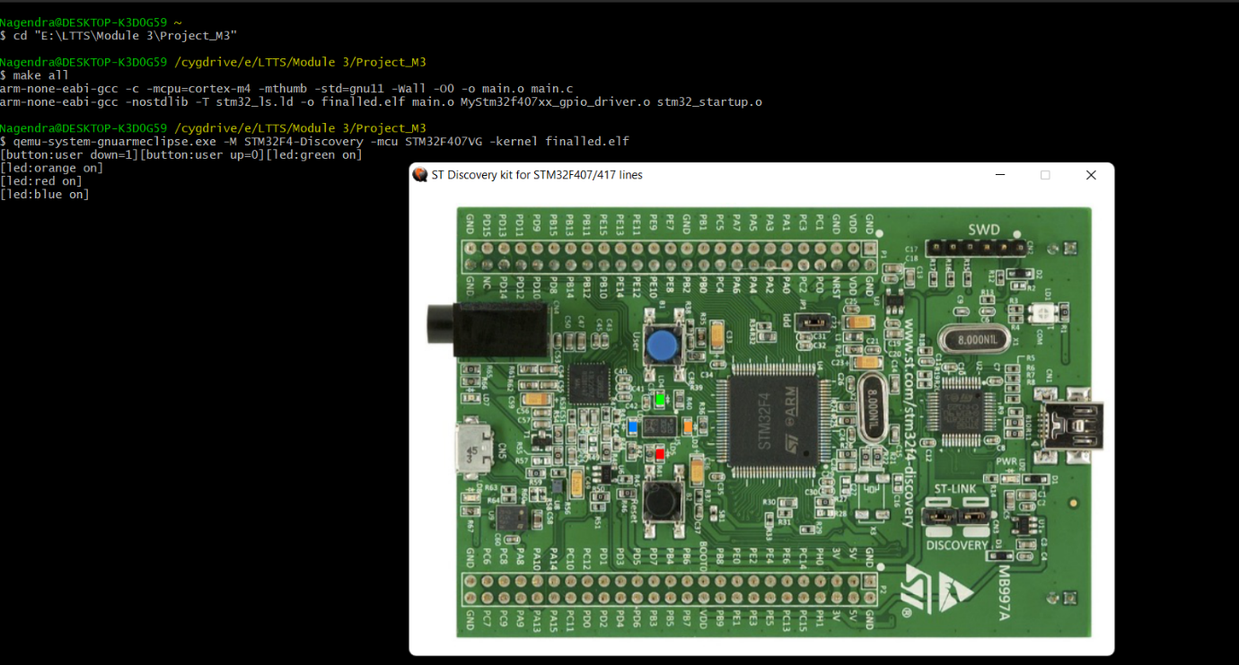

**Figure 5.3 Button pressed twice hence all LEDs are off**

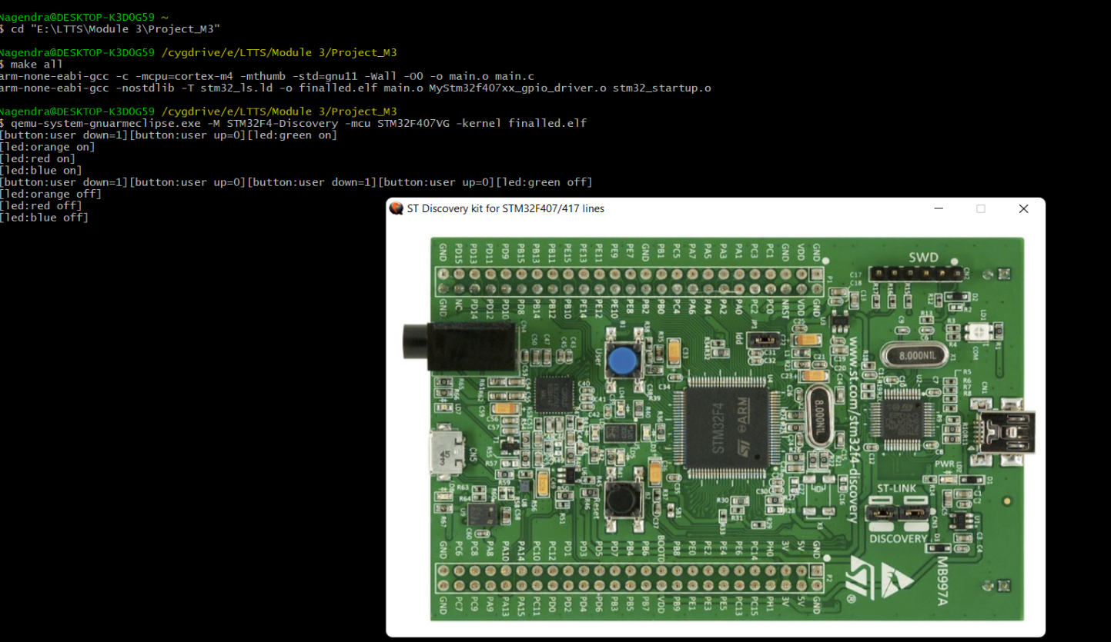

**Figure 5.4 Button is pressed thrice hence LEDs on in clockwise direction**

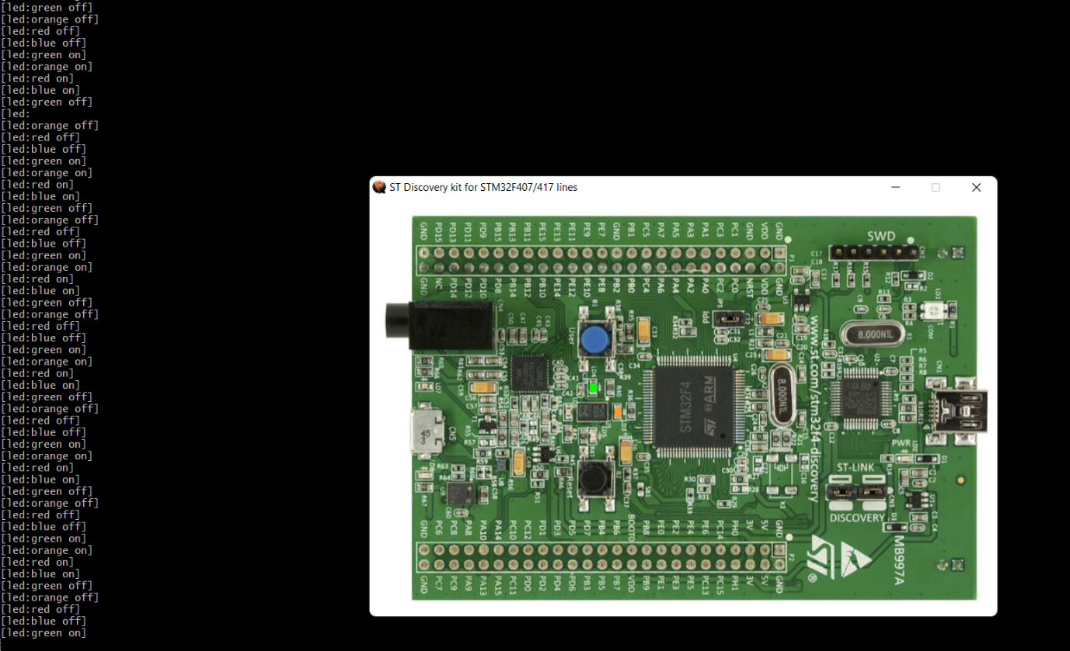

**Figure 5.5 Button is pressed four times hence LEDs on in anti-clockwise direction**

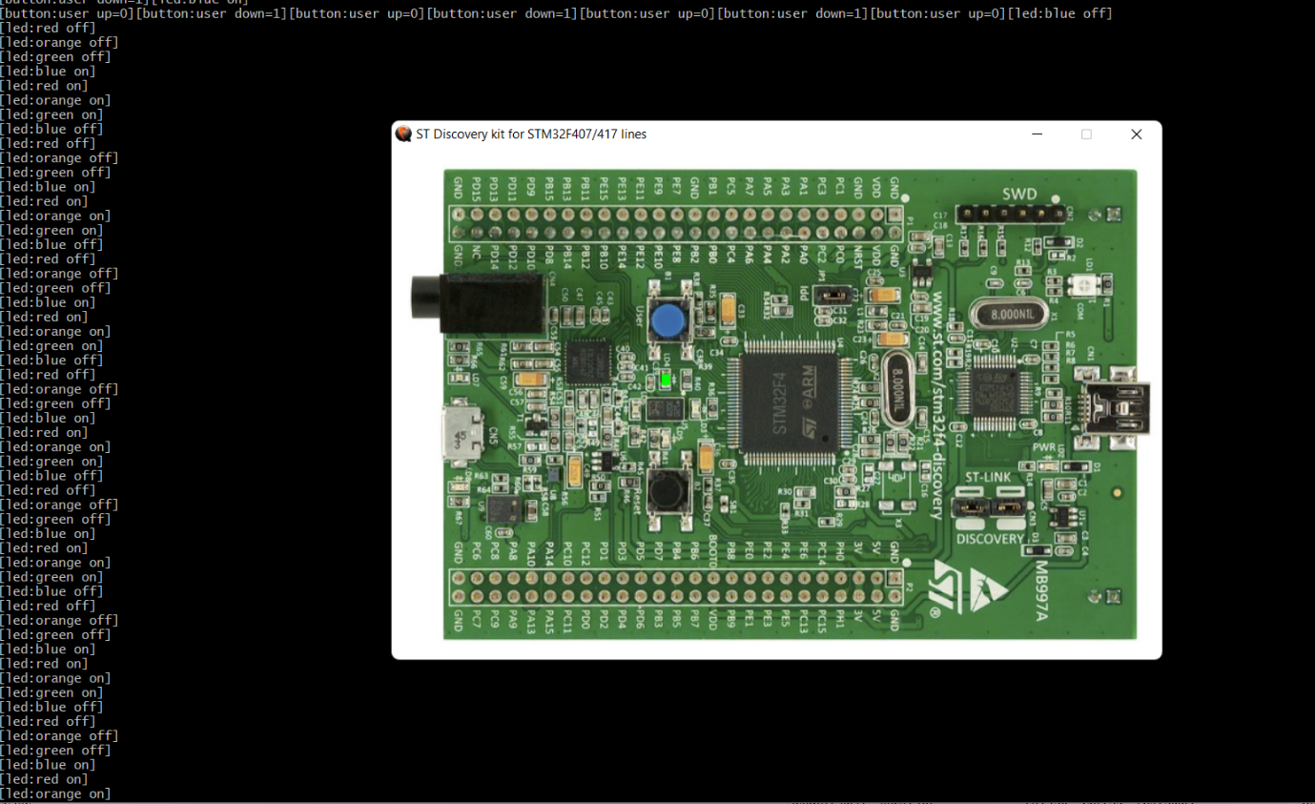

**6.APPLICATION**

# Automotive Application

* Flight System.
* Train System.
* Home Automation System.
* Industrial Application.

**7. REFERENCES**

* https://www.sciencedirect.com/topics/engineering/keyless-entry-system